Residence Halls
To check into the residence halls, please proceed to the front desk of HILL = Hillenbrand Residence Hall, or FSTC = First Street Towers Central, to check in and receive your room key. The small map below indicates the location of the residence halls, the Earhart dining hall, the McCutcheon parking garage, and the Lafayette Limo Follett’s Purdue West stop which is approximately a 5-minute walk to the residence hall lobbies.

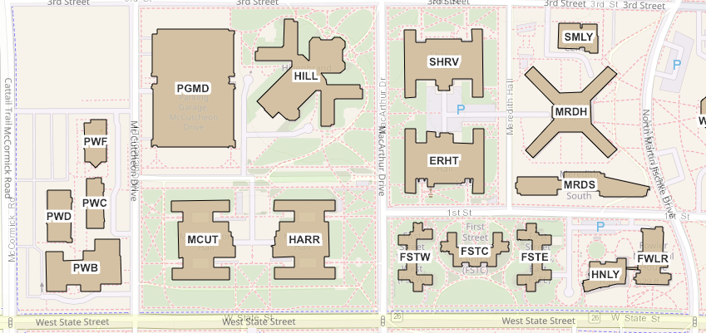

HILL = Hillenbrand Residence Hall
FSTC, FSTW, FSTE + First Street Towers Residence Hall (Central, West, East)
ERHT = Earhart Dining Hall and Earhart Residence Hall
PGMD = McCutcheon Parking Garage
Red X = Follett’s Purdue West Lafayette Limo stop
Red arrows indicate locations of lobbies to check in and the Earhart Dining Hall entrance

